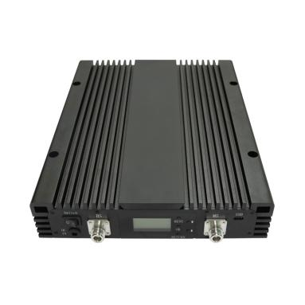
Digital Tri Band 1800+2100+3500MHz Pico Band-adjustable Repeater
Model: AT-DS-DWN78-20

Product Features:
- Digital bandwidth-adjustable features allow for seamless adaptability to different frequency bands.
- LCD display the input/output signal strength.
- Auto isolation detection.
- Improve any three mobile networks at the same time.
- Built-in Auto Gain Control (AGC)& Auto Level Control (ALC).
- Center frequency movable.
- OMS Lite for remote/local control and monitoring(Optional)

Working Schematic Diagram
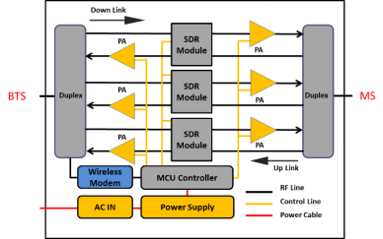

Application Scenario:


Technical Specifications:
AT-DS-DWN78-20 | B3(1800) | B1(2100) | N78(3500)

Frequency Range  (MHz,adjustable) | Uplink  (adjustable) | 1710-1730 MHZ | 1920-1940MHZ | 3450-3550 MHZ
Frequency Range  (MHz,adjustable) | Uplink  (adjustable) | 1730-1750 MHZ | 1940-1960MHZ | 3450-3550 MHZ
Frequency Range  (MHz,adjustable) | Uplink  (adjustable) | 1750-1780 MHZ | 1960-1980MHZ | 3450-3550 MHZ
Frequency Range  (MHz,adjustable) | Downlink  (adjustable) | 1805-1825 MHZ | 2110-2130MHZ | 3450-3550 MHZ
Frequency Range  (MHz,adjustable) | Downlink  (adjustable) | 1825-1845 MHZ | 2130-2150MHZ | 3450-3550 MHZ
Frequency Range  (MHz,adjustable) | Downlink  (adjustable) | 1845-1875 MHZ | 2150-2170MHZ | 3450-3550 MHZ
Number of Sub-bands |  | 3 | 3
Bandwidth per sub-band |  | 5-75 MHz adjustable | 5-60MHz adjustable | 5-100 MHz adjustable
Max.Gain(dB) | Uplink | 70士2dB | 70士2dB | 70士2dB
Max.Gain(dB) | Downlink | 75士2dB | 75士2dB | 75士2dB
Manual Gain Control |  | 31 dB in step of 1dB
Automatic Gain Control |  | ≥20 dB
Gain Flatness(per sub-band) |  | ≤±3.5 dB(peak-to-peak)
Max.Input Power Without Damage |  | 0 dBm
Output Power(dBm) | Uplink | 20±2dBm | 20±2dBm | 20±2dBm
Output Power(dBm) | Downlink | 23±2dBm | 23±2dBm | 23±2dBm
out of Band Gain | 0.2≤f offset cw<1.0MHz | ≤60dB
out of Band Gain | 1.0≤f offset cw<5.0MHz | ≤45dB
out of Band Gain | 5.0≤f offset cw<10.0MHz | ≤45dB
out of Band Gain | 10MHz≤f_offset_cw | ≤35dB
Spurious Emission | 9KHz-1GHz | ≤-36dBm
Spurious Emission | 1GHz-12.75GHz | ≤-30dBm
ACRR | ±10/20MHz | ≤-36dBc/30KHz
ACRR | ±20/40MHz | ≤-40dBc/30KHz
EVM |  | ≤6% | ≤6% | ≤3.5%
Frequency Stability |  | ≤±0.01 ppm
Noise Figure |  | ≤8dB
VSWR |  | ≤2
System Delay |  | ≤6μs
RF Connector |  | N-Female
Impedance |  | 50Ω
Power Supply | Input | AC100~240V,50/60 Hz
Power Supply | Output | DC24V/4.2A
Power Consumption |  | ≤70W
Dimensions |  | 330*258*95mm
Weight |  | ≤7kgs
IP Rating |  | IP30
Operating Temperature |  | -10℃ to 60℃
NMS | Local | RJ45
NMS | Remote | Via Cloud-based NMS(optional)

Technical specification is subject to change without prior notice.

